**Lucy Mae U. Dalisay**

1. 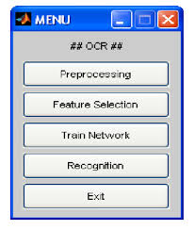**Menu-Based interface**

Is easy to use and user do not need to enter commands to work with the interface. In command line interface there are a lot of commands to remember and it is used by technical people. but menu-based interface gives ease to our work.

1. **Form-Based user interface**

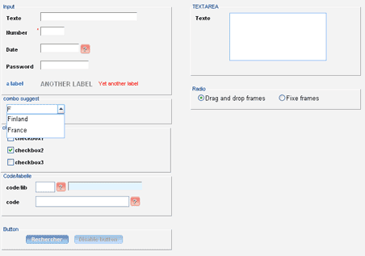

Are wide spread and are a very important means of interacting with a DBMS. They are easy to use and have the advantages that the user does not need special knowledge about database language like SQL.

1. **Graphical user interface**

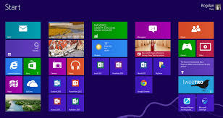

Is important part of software application programming in the area of human -computer interaction. Its goals to enhance the efficiency and ease of use for the underlying logical design of a stored program, a design discipline named usability.

1. **Natural Language Interface**

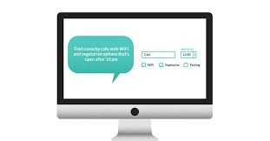

Is an interface that allows user to interact with the computer using a human language such as English or Chinese as opposed to using a computer language , command line interface or a graphical user interface.

1. **Speech Input and Output**

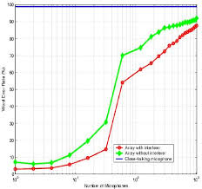

With the help of technology, user can easily control device and create documents by speaking. Speech recognition allows documents to be creates faster because the software generally produces word as quickly as they unuttered. This is usually much faster than a person can type.

1. 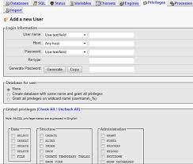**Interface of DBM**

Play an important role in coordinating the system that data analysis use for translating numbers into strategic business plan. In today digital world, DBAs are in high demand to ensure organization can easily access information on desktop, laptop, tablets and smartphone apps.